Assignment 5

- (20 pts.) Write a class SpiralBug that drops flowers in a spiral pattern (see below). Test your class.
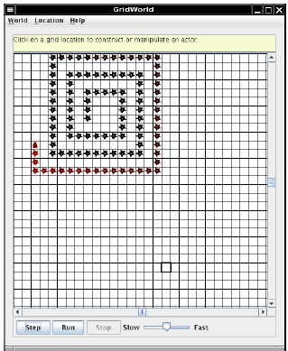

- Read part five in the Grid World Case Study.

